Experiment 1: Implementation of cryptanalysis on caesar cipher.

Here is a sample Encrypted Message:
GFS WMY OG LGDVS MF SFNKYHOSU ESLLMRS, PC WS BFGW POL DMFRQMRS, PL OG CPFU MUPCCSKSFO HDMPFOSXO GC OIS LMES DMFRQMRS DGFR SFGQRI OG CPDD GFS LISSO GK LG, MFU OISF WS NGQFO OIS GNNQKKSFNSL GC SMNI DSOOSK. WS NMDD OIS EGLO CKSJQSFODY GNNQKKPFR DSOOSK OIS 'CPKLO', OIS FSXO EGLO GNNQKKPFR DSOOSK OIS 'LSNGFU' OIS CGDDGWPFR EGLO GNNQKKPFR DSOOSK OIS 'OIPKU', MFU LG GF, QFOPD WS MNNGQFO CGK MDD OIS UPCCSKSFO DSOOSKL PF OIS HDMPFOSXO LMEHDS. OISF WS DGGB MO OIS NPHISK OSXO WS WMFO OG LGDVS MFU WS MDLG NDMLLPCY POL LYEAGDL. WS CPFU OIS EGLO GNNQKKPFR LYEAGD MFU NIMFRS PO OG OIS CGKE GC OIS 'CPKLO' DSOOSK GC OIS HDMPFOSXO LMEHDS, OIS FSXO EGLO NGEEGF LYEAGD PL NIMFRSU OG OIS CGKE GC OIS 'LSNGFU' DSOOSK, MFU OIS CGDDGWPFR EGLO NGEEGF LYEAGD PL NIMFRSU OG OIS CGKE GC OIS 'OIPKU' DSOOSK, MFU LG GF, QFOPD WS MNNGQFO CGK MDD LYEAGDL GC OIS NKYHOGRKME WS WMFO OG LGDVS.

Step:1
Open the encrypted message only in Notepad.

Step2:
Find the frequency of each letter in the encrypted message. to find the frequency of all
the letters appearing in the intercept. For this intercept we get the values given in the table below.

Step3:
Follow the table below to find the characters to be substituted for the given encrypted
message.

27

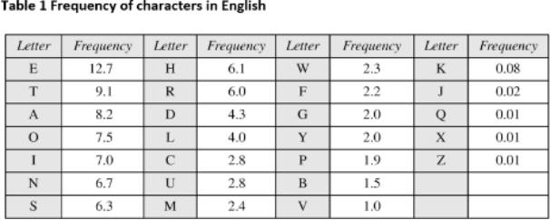

Step4:
Click ctrl+F in the notepad

Click the check box: Match case Step 5:
Start substituting one by one letters by following the sequence
S → e | O → t | I → h | G → o | F → n | M → a | X → x
W → wB → k | U → d | D → l | K → r | P → i | L → s V → v
H → p | A → b | X → x | Y → y | E → m | N →c C→f
R →g | Q → u | J → q

Step 6:
Output:-

Final decrypted text will be as shown below.

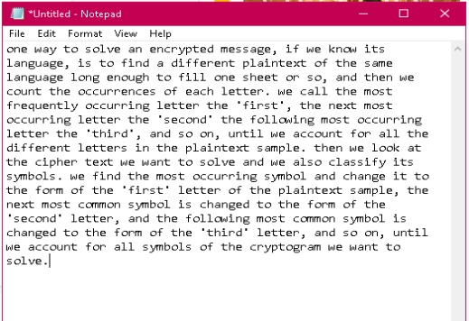

Result:-
Successfully performed cryptanalysis of the Caesar cipher using frequency analysis to identify the key and decrypt the ciphertext. The original plaintext was recovered successfully, demonstrating the effectiveness of frequency analysis in breaking simple substitution ciphers.

